Assignment-Hierarchical Queries (15-5-23)

LMS Dataset SQL File

Tables

SELECT * FROM LMS_MEMBERS;

SELECT * FROM LMS_BOOK_details;

SELECT * FROM LMS_BOOK_ISSUE;

SELECT * FROM LMS_FINE_DETAILS;

SELECT * FROM LMS_SUPPLIERS_DETAILS;

Q1) Fetch last 5 rows from LMS_Members Table, order by their

Registration.

Ans.

METHOD 1.

SELECT *

FROM LMS_MEMBERS

ORDER BY DATE_REGISTER DESC

FETCH FIRST 5 ROWS ONLY;

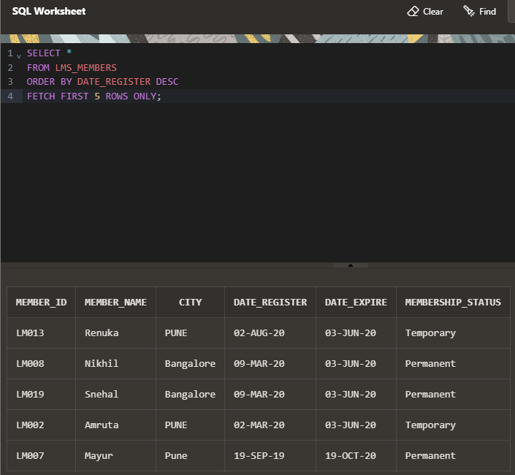

METHOD 2.

Select Member_ID, Member_Name, City, Date_register

From LMS_Members

order By Date_register OffSET (select count(*) - 5 from LMS_Members) Rows

fetch next 5 rows only;

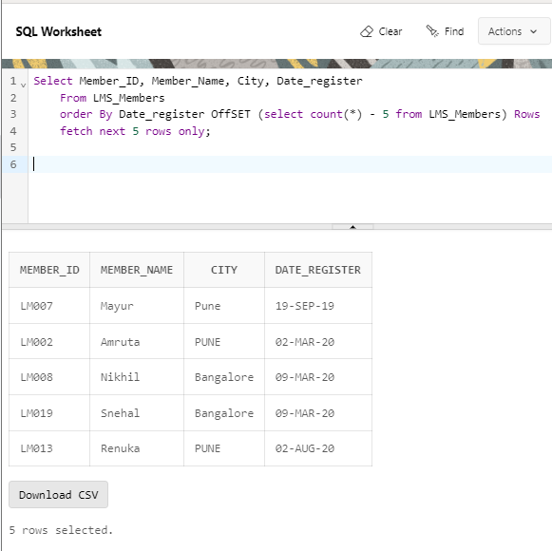

Q2) Write a query to display Member name, Book Title, Issue and

return date then show the hierarchy of tables (Grandparent -

parent-child relationship)

Ans.

Tables used

LMS members - member name (Member_id) = CHILD

LMS_BOOK_ISSUE - issue & return date (Member_id)(BOOK_CODE) = PARENT

LMS_BOOK_details - BOOK TITLE (BOOK_CODE) =GRAND PARENT

ATTEMPT 1:

SELECT M. MEMBER_NAME, BD.BOOK_TITLE, BI.DATE_ISSUE, BI.DATE_RETURN

FROM LMS_MEMBERS M

LEFT JOIN LMS_BOOK_ISSUE BI

ON M.MEMBER_ID=BI.MEMBER_ID

LEFT JOIN LMS_BOOK_DETAILS BD

ON BI.BOOK_CODE=BD.BOOK_CODE;

NOTE-

JUST JOINED NO RELATION

ATTEMPT 2:

METHOD 1.

SELECT M.MEMBER_NAME, BD.BOOK_TITLE, BI.DATE_ISSUE, BI.DATE_RETURN, 'LMS_BOOK_DETAILS' AS Hierarchy

FROM LMS_BOOK_DETAILS BD

JOIN LMS_BOOK_ISSUE BI ON BD.BOOK_CODE = BI.BOOK_CODE

JOIN LMS_MEMBERS M ON BI.MEMBER_ID = M.MEMBER_ID

UNION ALL

SELECT M.MEMBER_NAME, BD.BOOK_TITLE, BI.DATE_ISSUE, BI.DATE_RETURN, 'LMS_BOOK_ISSUE' AS Hierarchy

FROM LMS_BOOK_ISSUE BI

JOIN LMS_MEMBERS M ON BI.MEMBER_ID = M.MEMBER_ID

JOIN LMS_BOOK_DETAILS BD ON BI.BOOK_CODE = BD.BOOK_CODE

UNION ALL

SELECT M.MEMBER_NAME, BD.BOOK_TITLE, BI.DATE_ISSUE, BI.DATE_RETURN, 'LMS_MEMBERS' AS Hierarchy

FROM LMS_MEMBERS M

JOIN LMS_BOOK_ISSUE BI ON M.MEMBER_ID = BI.MEMBER_ID

JOIN LMS_BOOK_DETAILS BD ON BI.BOOK_CODE = BD.BOOK_CODE;

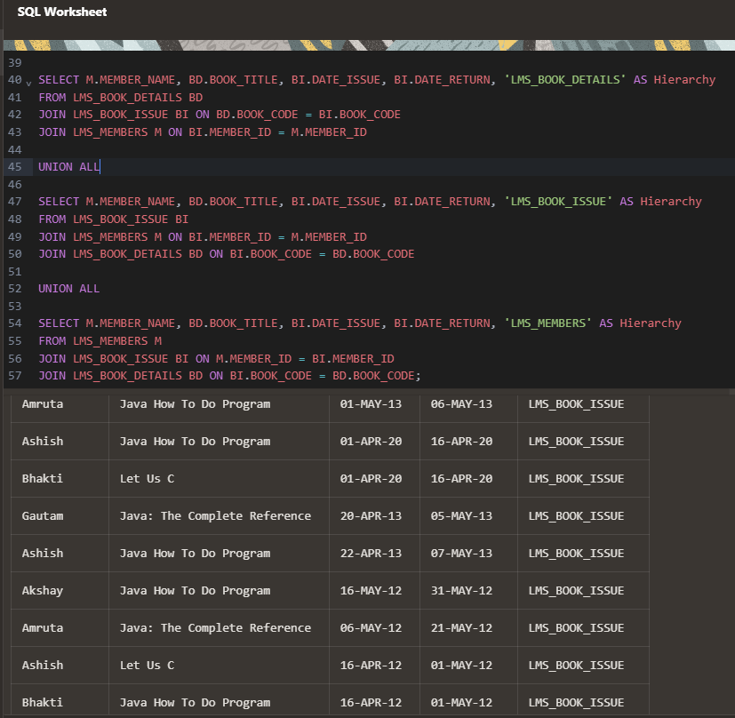

METHOD 2.

SELECT lms_members.MEMBER_NAME,

lms_Book_Details.BOOK_TITLE,

lms_book_issue.DATE_ISSUE,

lms_book_issue.DATE_RETURN

FROM lms_Book_Details

JOIN lms_book_issue

ON (lms_Book_Details.BOOK_CODE = lms_book_issue.BOOK_CODE)

JOIN lms_members

ON (lms_book_issue.MEMBER_ID = lms_members.MEMBER_ID);

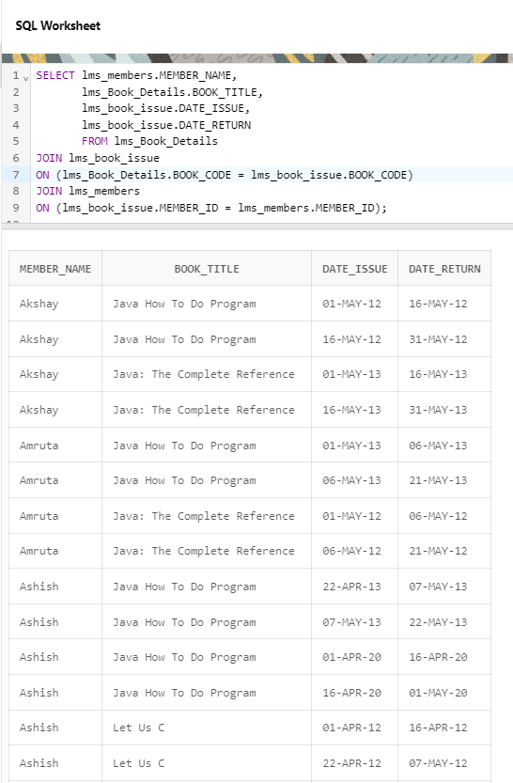

Q3) Write a query to compare the price of different books

according to their book editions. (using Lead/Lag function)

Ans.

Attempt 1.

SELECT BOOK_TITLE, PRICE, BOOK_EDITION,

LAG(PRICE) OVER (ORDER BY BOOK_EDITION)

AS PREVIOUS_EDITION_VALUE

FROM LMS_BOOK_details;

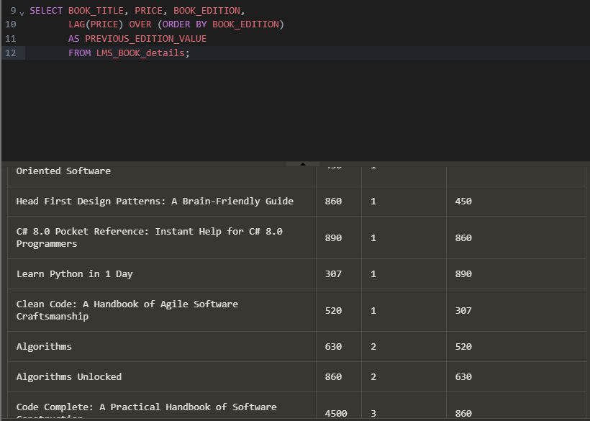

Attempt 2.

SELECT

BOOK_TITLE,

PRICE,

BOOK_EDITION,

LAG(PRICE) OVER (PARTITION BY BOOK_TITLE ORDER BY BOOK_EDITION)

AS PREVIOUS_EDITION_VALUE

FROM

LMS_BOOK_details;

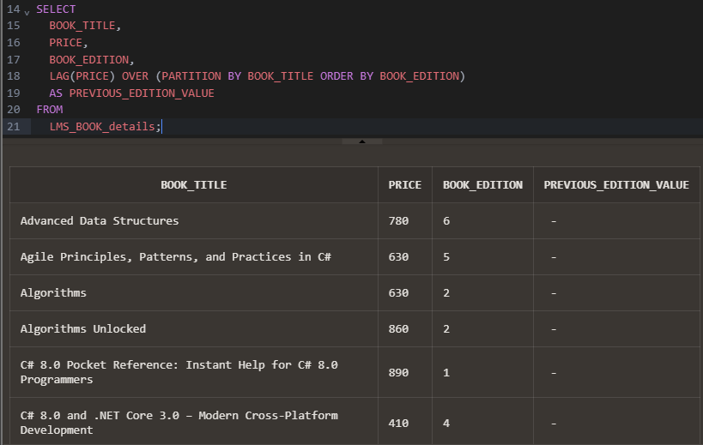

Attempt 3.

SELECT

BOOK_TITLE,

BOOK_EDITION,

PRICE,

LAG(PRICE) OVER (PARTITION BY BOOK_TITLE ORDER BY BOOK_EDITION) AS PREVIOUS_PRICE,

LEAD(PRICE) OVER (PARTITION BY BOOK_TITLE ORDER BY BOOK_EDITION) AS NEXT_PRICE

FROM

LMS_BOOK_details;

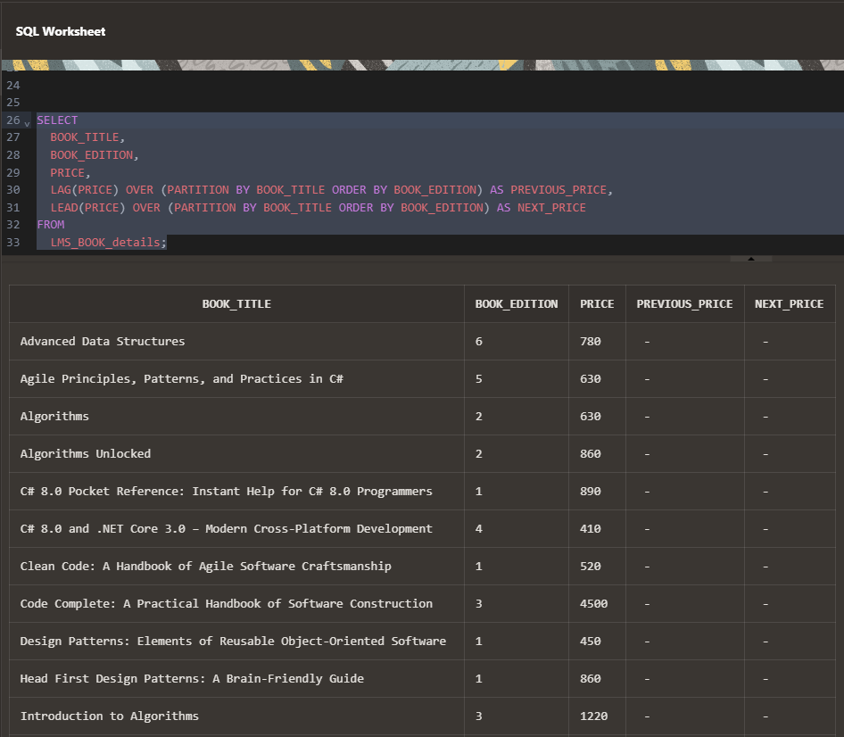

LAG-to fetch the price of the previous book edition within the same book title group

lEAD-fetches the price of the next book edition within the same book title group

PARTITION BY BOOK_TITLE-ensures that the functions operate within each book title group

ORDER BY BOOK_EDITION-specifies the order

Actual Ans-

SELECT * FROM LMS_BOOK_DETAILS;

Select Book_title, Category, Book_Edition, Price,

Lag(Price) over(PARTITION bY Category order by Book_edition ASC)

AS Price_Comp

from lms_book_details;

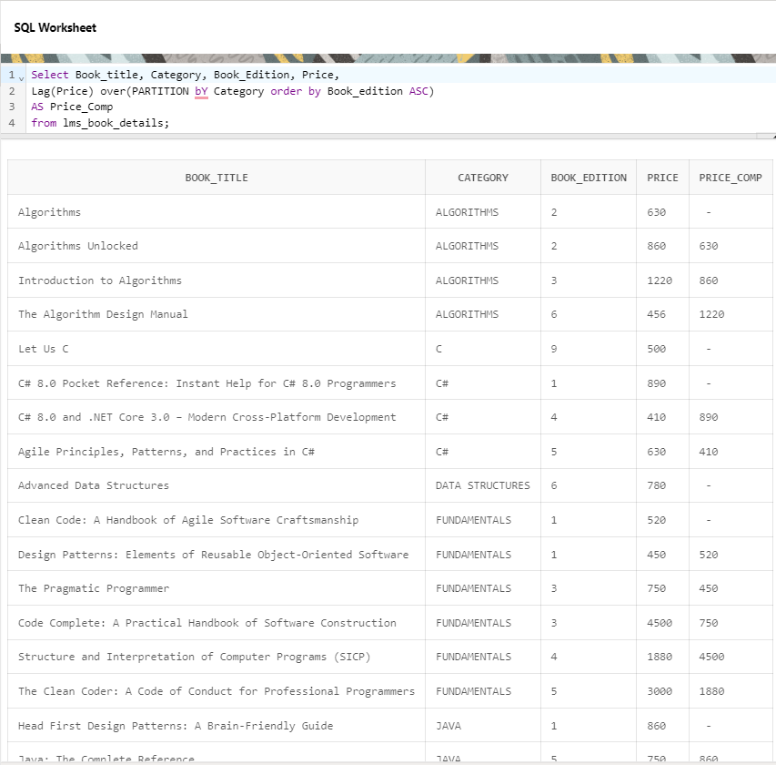

Q4) List down the books according to Rack number except A1 and

A2.

Ans.

Attempt 1.

SELECT * FROM LMS_BOOK_details

ORDER BY RACK_NUM;

WHERE RACK_NUM <> A1 AND

WHERE RACK_NUM <> A2 ;

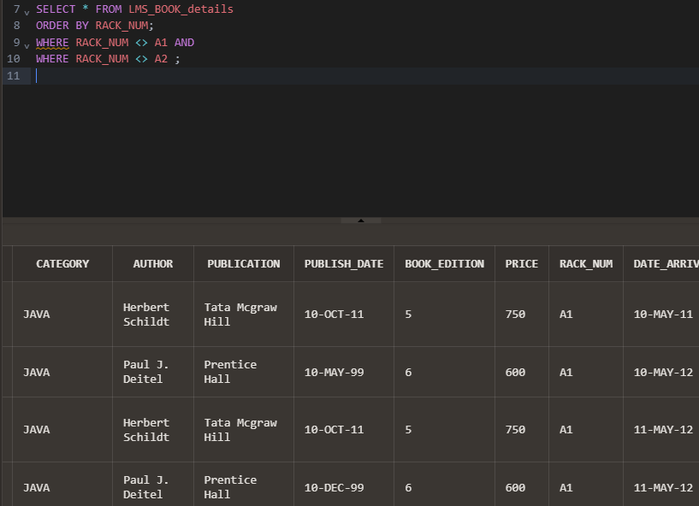

Attempt 2.

THE ORDER BY WILL COME AFTER WHERE SINCE FIRST DATA IS FILTERED (; RACK_NO <> A1, A2)AND THEN ITS PUT IN ORDER.

SELECT *

FROM LMS_BOOK_details

WHERE RACK_NUM <> 'A1' AND

WHERE RACK_NUM <> 'A2'

ORDER BY RACK_NUM;

OR

SELECT *

FROM LMS_BOOK_details

WHERE RACK_NUM NOT IN ('A1','A2')

ORDER BY RACK_NUM;

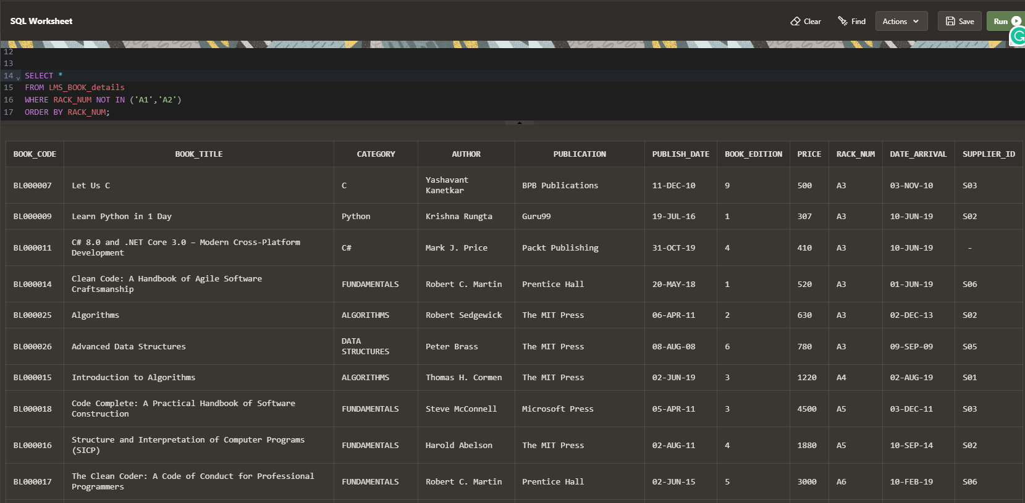

ACTUAL ANS-

Select Book_Title, Rack_Num from LMS_Book_Details

Order By Rack_Num

Offset (Select Count(Rack_Num)

from LMS_Book_details

where Rack_Num = 'A1' or Rack_Num = 'A2') Rows;

